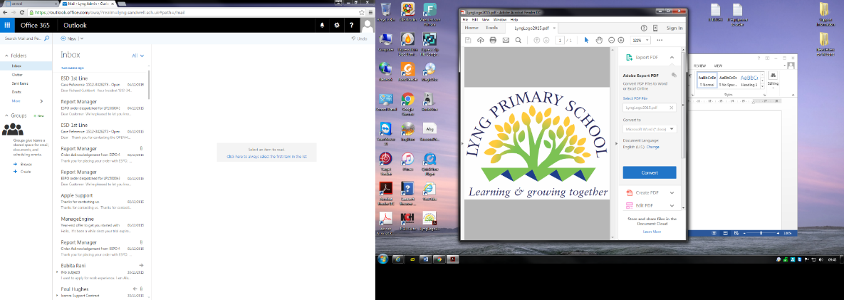

Headteacher: Mr A Fowler
Horton Street, West Bromwich, West Midlands, B70 7SQ.
Telephone: 0121 553 1480 - Email: lyng.admin@lyng.sandwell.sch.uk - Website: www.lyng.sandwell.sch.uk
1 x SEN Learning Support Assistants (Grade B)
SEN Allowance
Required immediately

Hours: 32 hours per week (Mon-Fri, 30 minutes lunch)
Staff are expected to work throughout mainstream school supporting class teachers where required to include SEN children. We wish to appoint a enthusiastic, passionate and motivated individual who loves working with young children, to enable them to thrive.
- Must have an in-depth knowledge of child development
- Have previous experience of working with young children in an educational setting
- Well motivated and bring new ideas to help enrich the lives of young children
- Communicate with parents and stakeholders
- An understanding of Child Protection and Safeguarding
- Experience of delivering Interventions, plan and deliver 1:1 and small group activities
- To work closely with team members to support the set-up of individual schedules and work systems.
- To help the pupil work as independently as possible.
- To help supervise students at designated lunch or break times as directed by the SENCo.
- To help in the preparation and organisation of classroom resources including making adjustments in classroom layout when needed for the child.
- To contribute to discussion of individual targets in the process of reviews.
- To lead small group activities within a class, as directed by the teacher, to support students.

For any further information please contact Victoria Durnall, Business Director and PA to Headteacher email Victoria.durnall@lyng.sandwell.sch.uk
Application forms are available on line, and returnable directly to the school - Lyng Primary School - Home
Lyng Primary School is committed to safeguarding and promoting the welfare of children and young people and expects all staff and volunteers to share this commitment. Closing Date: 30th August 2026
Lyng Primary School is committed to safeguarding and promoting the welfare of children. We ensure that all our recruitment and selection practices reflect this vision. Successful candidates will be subject to an Enhanced DBS check along with other relevant safeguarding and employment checks. Sandwell MBC is an Equal Opportunities employer.
This post is exempt from the Rehabilitation of Offenders Act 1974 and is eligible for an enhanced DBS check including a Children's Barring List Check. If you are barred from working with children you are breaking the law if you apply for this post. Shortlisted candidates applying for a regulated activity role will be asked to complete a self-declaration and disclosure form. Any disclosures declared on this form will be discussed at interview.
Pre-employment checks will be carried out in line with KCSIE
This post is covered by Part 7 of the Immigration Act (2016) and therefore the ability to speak fluent and spoken English is an essential requirement for this role.
Please ensure all application forms are signed when sending via email. If you are successful in being short-listed for interview, you will be contacted via email. Please ensure you check your junk/spam boxes as well as your inbox in case any correspondence has been delivered there. If you do not hear from us you should presume on this occasion, you have been unsuccessful.
Online Search
An online search will be undertaken on all shortlisted candidates. This search does not form part of the shortlisting process and you will have the opportunity to discuss any issues of concern that may arise from this search at the interview.

